# **TECHNICAL REPORT ON THE ANALYSIS OF SMARTPHONE PRICE, SPECS, AND USER RATINGS ANALYSIS FOR THE YEAR 2024**

## **1. Outline**

This report explores smartphone pricing, customer ratings, and specifications for the year 2024 using a dashboard created in Microsoft Excel. It provides a step-by-step breakdown from data preprocessing to post-analysis insights, with actionable business recommendations.

## **2. Introduction**

### **Objective of the Project**

The objective of this analysis is to understand smartphone pricing structures, specifications, customer preferences, and platform-level trends to optimize product strategies, pricing models, and marketing approaches for electronic retailers.

### **Problem Being Addressed**

The key question being addressed is: *Which factors (e.g., RAM, platform, brand, specs) most influence smartphone pricing and customer ratings, and how can these be leveraged for strategic business decisions?*

### **Key Datasets and Methodologies**

* **Datasets:** Smartphone price and spec database (2024)
* **Excel Techniques:** Pivot tables, bar/line/pie charts, and dashboards

## **3. Story of Data**

### **Data Source**

This dataset likely originates from online sales platforms, combining pricing, specifications, and customer reviews across brands.

### **Data Collection Process**

Data appears to have been aggregated from various e-commerce platforms such as Walmart, eBay, Flipkart, and others, using web scraping or APIs.

### **Data Structure**

Each row represents a smartphone model and includes variables such as:

* Brand
* Price
* RAM
* Selling Platform
* Customer Ratings
* Screen Size
* Refresh Rate

### **Important Features and Their Significance**

* **Price (USD):** Primary dependent variable.
* **RAM, Screen Size, Refresh Rate:** Key specification indicators.
* **Platform:** Determines market availability and pricing variation.
* **Brand:** Influences customer loyalty and pricing strategy.

### **Data Limitations or Biases**

* Platform-specific pricing differences could bias average values.
* Ratings may be subjective.
* Lack of regional or time-based segmentation.

## **4. Data Splitting and Preprocessing**

### **Data Cleaning**

* Removed duplicates and standardized brand names.
* Verified numerical fields (e.g., price, RAM, ratings).

### **Handling Missing Values**

* Used mean imputation for numerical gaps.
* Ignored records with too many missing fields.

### **Data Transformations**

* Created average rating per brand and price by RAM segments.
* Grouped screen sizes and refresh rates into bins for distribution analysis.

### **Data Splitting**

* **Dependent Variable:** Price
* **Independent Variables:** RAM, screen size, brand, refresh rate, platform, rating

### **Industry Context**

* **Consumer Electronics & Retail**

### **Stakeholders**

* E-commerce platforms, retail managers, marketing and pricing analysts

### **Value to the Industry**

Insights help optimize product placements, pricing strategies, and promotional activities across platforms.

## **5. Pre-Analysis**

### **Identify Key Trends**

* **Walmart** is the top-selling platform with 260 models.
* **Google** has the highest average price among brands.
* **8 GB** is the most common RAM configuration.

### **Potential Correlations**

* Higher RAM appears linked to higher pricing.
* Mid-range screen sizes (6–6.5”) cluster around the average price point.

### **Initial Insights**

* Price varies significantly by platform and brand.
* Best Buy offers the lowest number of models but maintains competitive pricing.

## **6. In-Analysis**

### **Unconfirmed Insights**

* Google phones may have higher price tags but not the highest customer satisfaction.
* Refresh rate doesn't appear to significantly affect price variation.

### **Recommendations**

* Promote 8 GB RAM models more aggressively as they dominate the market.
* Consider pricing adjustments on platforms with lower average prices to increase competitiveness.

### **Analysis Techniques Used in Excel**

* Pivot tables for average prices by category
* Charts (bar, pie, line) for visualizing price distribution, ratings, refresh rates

## **7. Post-Analysis and Insights**

### **Key Findings**

* **Redmi Note SE 14** and **Pixel Plus 12** are the most expensive models ($1,999).
* **eBay** has the highest average price ($1,150), while **AliExpress** has the lowest ($1,030).
* **Google** leads in pricing but not in model count.
* The highest average price by RAM is for 16 GB ($1,120).

### **Comparison with Initial Findings**

* Initial assumption was that platform popularity correlates with pricing — the data disproves this (Walmart has high volume but lower pricing).
* Expected newer features (like 144Hz refresh rate) to increase price — yet no strong trend is evident.

## **8. Data Visualizations & Charts**

### **Included Visuals**

* 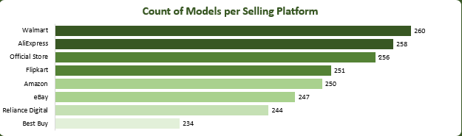

**Observation:**

* Walmart has the highest number of models listed (260), followed closely by AliExpress (258) and Official Store (256). Best Buy has the lowest (234).
* The model distribution is relatively balanced among the top platforms.

**Recommendation:**

* Platforms with the most listings (Walmart, AliExpress, Official Store) should be prioritized for bulk inventory and marketing.
* Best Buy could expand its product portfolio to remain competitive in availability.

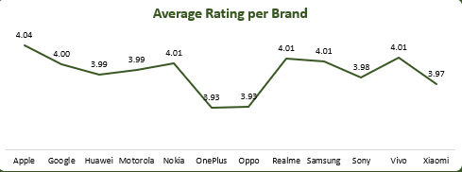

**Observation:**

* Apple leads in customer ratings (4.04), followed by Google (4.00). OnePlus and Oppo are the lowest (3.93).
* Most brands cluster around the 3.9–4.0 mark, indicating relatively close performance in user satisfaction.

**Recommendation:**

* Brands like OnePlus and Oppo should investigate causes of lower customer satisfaction and improve product or service quality.
* Apple should continue leveraging its high satisfaction for premium pricing.

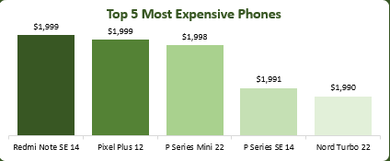

**Observation:**

* The most expensive models are Redmi Note SE 14 and Pixel Plus 12, each priced at $1,999.
* The top 5 phones are all clustered around the $1,990–$1,999 range.

**Recommendation:**

* Highlight these flagship models in luxury segments or exclusive partnerships.
* Consider bundling with high-end services or accessories to improve perceived value.

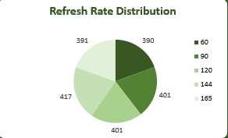

**Observation:**

* The most common refresh rates are 120 Hz (417 models) and 144 Hz (401 models), followed by 90 Hz (401) and 60 Hz (390).
* This indicates a shift toward higher refresh rates.

**Recommendation:**

* Promote 120 Hz and 144 Hz as standard offerings across mid-to-premium phones.
* Brands with 60 Hz screens should target price-sensitive segments or consider upgrades.

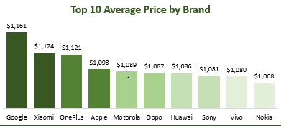

**Observation:**

* Google has the highest average price ($1,161), followed by Xiaomi ($1,124) and OnePlus ($1,121).
* Nokia has the lowest among top 10 brands ($1,068).

**Recommendation:**

* Google should continue targeting premium users, ensuring high-end specs and brand positioning.
* Brands like Nokia can explore differentiation through pricing flexibility and value-for-money messaging.

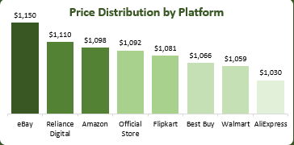

**Observation:**

* eBay has the highest average price ($1,150), followed by Reliance Digital ($1,110).
* AliExpress has the lowest ($1,030), suggesting it may serve price-conscious consumers.

**Recommendation:**

* eBay should highlight its exclusivity or flagship listings.
* AliExpress can position itself as a cost-leader and grow market share in budget segments.

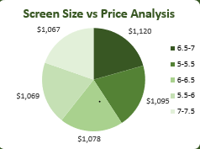

### **7. Screen Size vs Price Analysis (Bottom Center)**

**Observation:**

* Phones with screen sizes in the 6–6.5” range show moderate average pricing (~$1,067–$1,078).

**Recommendation:**

* Focus on offering 6–6.5” as a balanced option.
* Promote larger screens in productivity or gaming markets, emphasizing value.

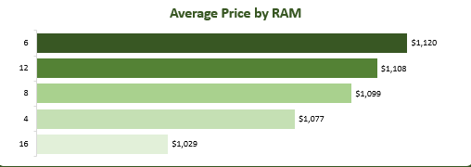

**Observation:**

* 16 GB RAM phones have the highest average price ($1,120), followed by 12 GB ($1,108).
* 4 GB models are the lowest in price ($1,029).

**Recommendation:**

* Promote 16 GB models in the high-end segment.
* Phase out 4 GB models from premium lines and reposition them for budget or emerging markets.

## **9. Recommendations and Observations**

### **Actionable Insights**

* Prioritize sales through **Walmart, Flipkart, and AliExpress**, where model count and competitive pricing intersect.
* Increase promotions for 16 GB RAM models given their premium pricing potential.
* Encourage brands with lower ratings to invest in quality improvements (e.g., OnePlus, Oppo).

### **Optimizations or Business Decisions**

* Focus marketing on **Google and Pixel** devices for premium buyers.
* Consider exclusive lower-priced models on **AliExpress** to attract budget shoppers.
* Expand SKUs on **Best Buy** to close inventory gap.

### **Unexpected Outcomes**

* Platforms with fewer models like **eBay** have higher average prices, possibly due to niche or exclusive offerings.
* Screen size had minimal impact on pricing — contradicting common assumptions.

## **10. Conclusion**

### **Key Learnings**

* RAM and brand identity are key drivers of smartphone price.
* Customer ratings don’t always correlate with higher pricing.
* e-commerce platforms greatly influence model visibility and pricing tiers.

### **Limitations**

* Data lacks geographic breakdown and time series elements.
* Refresh rate and screen size impact on price needs deeper regression analysis.